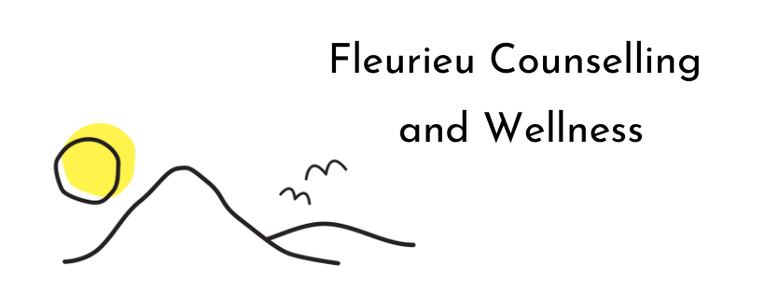
IFS CLIENT ENQUIRY FORM
Name: _________________________________
Mobile Phone: ( ) ___________May we leave a message? □ Yes □ No
E-mail: ____________________________May we email you? □ Yes □ No
Referred by: _____________________________
In person or zoom appointment? ____________
TO HELP ME HELP YOU……
Are you currently receiving mental health treatment from other providers? □ Yes □ No
If Yes, please provide details: ___________________________________________________________
Have you received mental health treatment previously?
□No
□Yes (Please provide details) ______________________________________
What exposure or experience have you had with IFS Therapy?
_________________________________________
_________________________________________
What are your goals for therapy? What would you like to address and/or achieve from this process?
_________________________________________
_________________________________________
Are you looking for regular sessions? Is so weekly, fortnightly, monthly etc or Casual sessions?
_________________________________________
_________________________________________
Is there any other information you would like me know?
_________________________________________

IFS Therapy sessions are 1hr $150, payment is due on the day of your appointment. These appointment are not reimbursable by medicare.

All appointments require 24hrs notice for cancellations to avoid the $75 late cancellation or missed appointment fee.

Thank you for this information, we will be in contact with you shortly.

Fleurieu Counselling & Wellness
E: hello@fleurieucounsellingandwellness.com
W: www.fleurieucounsellingandwellness.com

